
Indian Institute of Technology Hyderabad
Department of Electrical Engineering
Two-Stage Operational Transconductance Amplifier (OTA) Design
45 nm CMOS Technology (GPDK045) — Cadence Virtuoso / Spectre
Submitted by
Nimmala Sree Prabhath
Roll No: EE25MTECH11010
MTech (MVLSI)
Indian Institute of Technology Hyderabad

Abstract
This report documents the design and Cadence Spectre-based characterization of a two-stage Miller-compensated Operational Transconductance Amplifier (OTA) in 45 nm CMOS technology (GPDK045), implemented using I/O (thick-oxide) devices to safely support a 1.8 V supply. The design (L = 500 nm, 20 µA tail current) was verified through DC operating-point, AC (gain/phase), and transient simulations, with particular attention to open-loop gain, unity-gain bandwidth, and phase margin. AC characterization was performed at two input common-mode operating points — Vcm = 1.6 V and Vcm = 800 mV — to verify consistency of the small-signal response across the input common-mode range. Both bias points show a low-frequency gain of ≈48.88 dB, a unity-gain bandwidth of ≈29.65 MHz, and a measured phase margin of ≈51.17°, comfortably exceeding the 45° target and confirming that the Miller compensation network provides adequate stability margin for the intended application.

Table of Contents
1. Objective and Specifications 4
2. Circuit Schematic 4
3. AC Characterization at Vcm = 1.6 V 4
4. AC Characterization at Vcm = 800 mV 6
5. Summary 7

1. Objective and Specifications
The objective of this project was to design and characterize a two-stage Miller-compensated OTA in 45nm CMOS (GPDK045) using I/O (thick-oxide) devices to safely support a 1.8V supply. The design was verified through DC operating-point, AC (gain/phase), and transient simulations in Cadence Spectre, with particular attention to open-loop gain, unity-gain bandwidth, and phase margin at two input common-mode operating points — V_{cm} = 1.6V and V_{cm} = 800mV — to check consistency of the AC response across the input common-mode range.
Parameter | Specification
Technology Node | 45 nm CMOS (GPDK045), I/O (thick-oxide) devices
Topology | Two-stage OTA (Miller-compensated)
Supply Voltage | 1.8 V
Channel Length (L) | 500 nm
Tail Current | 60 µA
Miller Compensation Capacitor | 2 pF
Target Slew Rate | 20 V/µs
Target Phase Margin | Above 45°
Input Common-Mode Points Tested | Vcm = 1.6 V and Vcm = 800 mV
Simulator | Cadence Spectre (Virtuoso ADE-L)

2. Circuit Schematic
The OTA consists of a PMOS-input differential pair (M0/M1) with an NMOS current-mirror load (M3/N2) forming the first stage, followed by a common-source second stage (M7) biased by a tail current source. Miller compensation is realized using C₁ (series with an internal compensation resistor path) between the first and second stage output nodes, with C₂ as the output load capacitor. Bias currents for the differential pair and the second stage are set by a cascoded current-mirror bias network (M4, M5, M11) referenced from a 25µA bias current source (I₅).
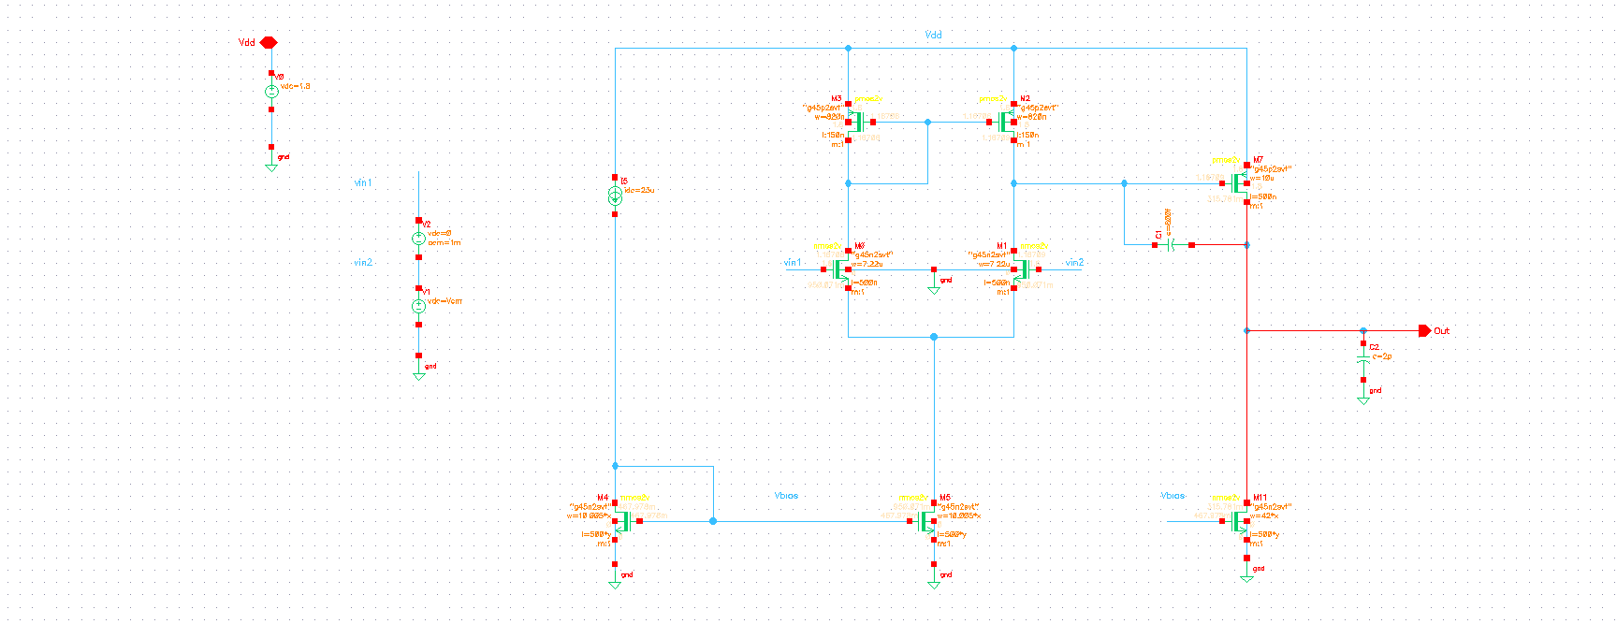
Fig. 2.1 — Two-stage OTA schematic with differential input pair, Miller compensation, and current-mirror biasing

3. AC Characterization at Vcm = 1.6 V
The first test point places the differential input common-mode voltage at Vcm = 1.6V, close to the positive supply rail, to check the OTA's gain and phase behavior near the upper end of its input common-mode range.

ADE Window — Setup
Three analyses were configured together: a DC operating-point analysis, an AC sweep from 100Hz to 100MHz for gain/phase extraction, and a transient analysis (0 to 1µs) for slew-rate characterization. Vcm was set to 1.6V as a design variable alongside the differential-pair bias variables x and y.
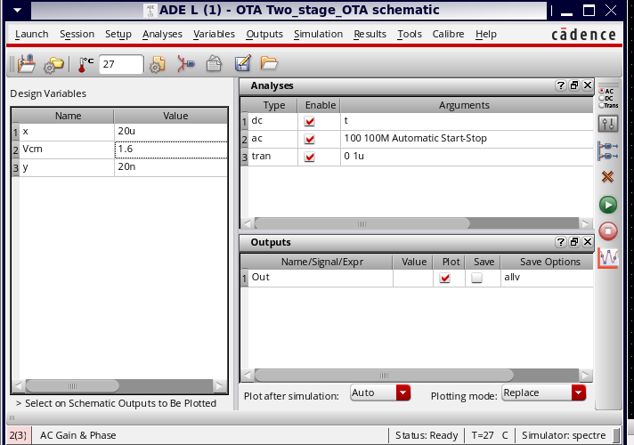
Fig. 3.1 — ADE-L setup: DC/AC/Transient analyses configured with Vcm = 1.6V

Operating Point Annotation
With the DC operating point solved, Cadence's annotate-OP-values feature was used to back-annotate Id, Vgs, Vds, gm and region for every transistor directly on the schematic, confirming all devices are correctly biased in saturation (region=2) for this common-mode setting.
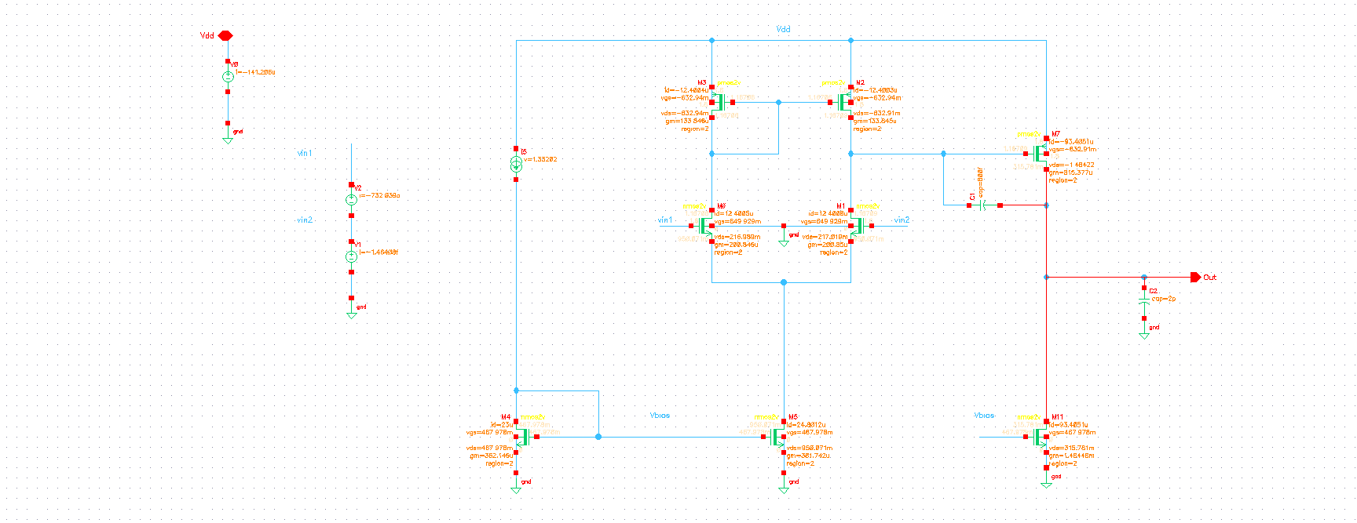
Fig. 3.2 — Schematic with annotated DC operating points (Vcm = 1.6V)

Simulation Output — AC Gain and Phase
The Bode plot shows a low-frequency (DC) gain of about 48.88dB, rolling off with a dominant pole set by the Miller compensation network. The phase starts near 180° at low frequency (as expected for this inverting/differential configuration) and falls off through the dominant and second pole. At the unity-gain crossover frequency of about 29.65MHz, the phase has fallen to about 51.17°, giving a measured phase margin of ≈51.17° at this bias point.
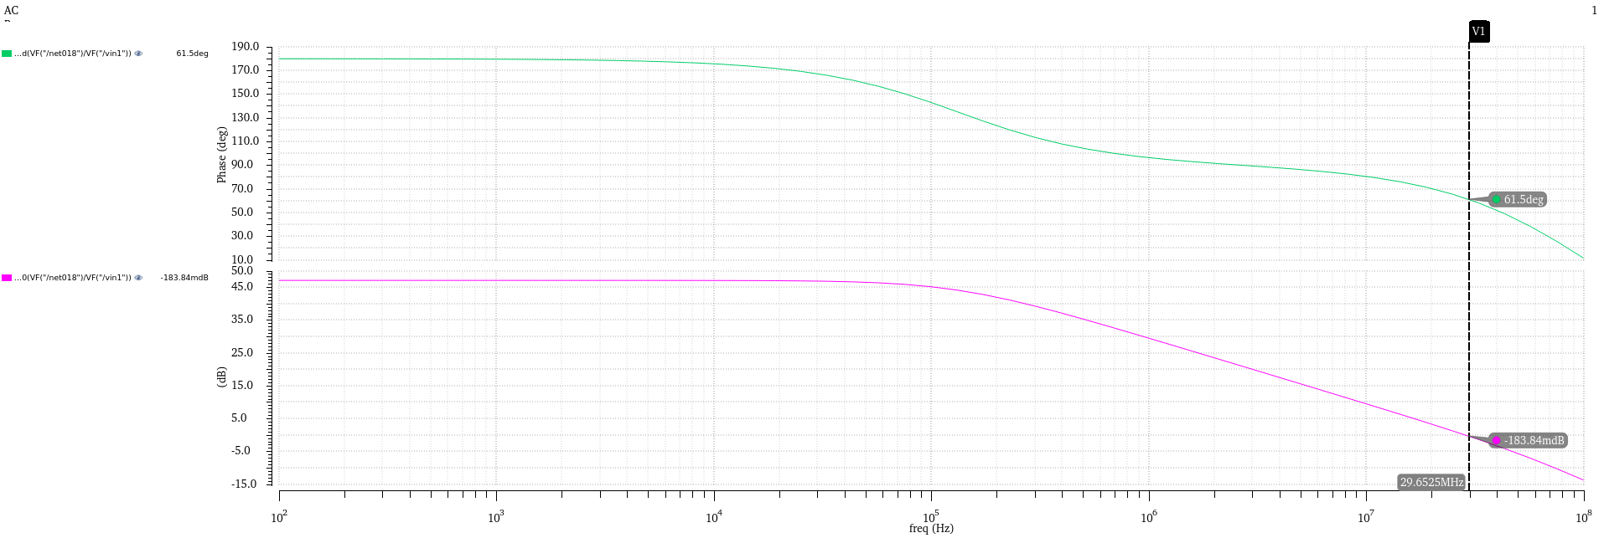
Fig. 3.3 — AC Gain (magenta) and Phase (green) vs. frequency, Vcm = 1.6V
Parameter | Value
Low-Frequency Gain | ≈ 48.88 dB
Unity-Gain Bandwidth (UGB) | ≈ 29.65 MHz
Phase at UGB | ≈ 51.17°
Measured Phase Margin | ≈ 51.17°

4. AC Characterization at Vcm = 800 mV
The second test point moves the common-mode voltage down to Vcm = 800mV, roughly mid-rail, to verify that the OTA's small-signal behavior stays consistent across a wider portion of the input common-mode range rather than being characterized at only one bias point.

ADE Window — Setup
The same DC and AC analyses were re-run with Vcm changed to 800mV, while x and y (the differential-pair sizing variables) were kept unchanged so that any difference in the result can be attributed to the shift in common-mode bias rather than a change in device sizing.
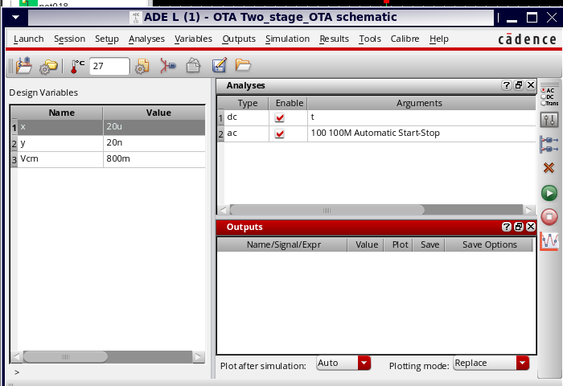
Fig. 4.1 — ADE-L setup: DC/AC analyses configured with Vcm = 800mV

Operating Point Annotation
The back-annotated operating points at this lower common-mode voltage again confirm all transistors remain in saturation, with the expected shift in individual Vgs/Vds values relative to the Vcm = 1.6V case as the input pair's headroom changes.
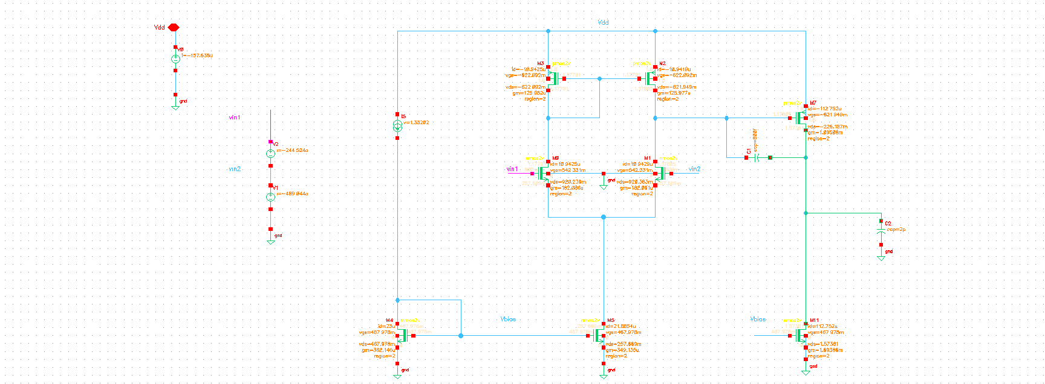
Fig. 4.2 — Schematic with annotated DC operating points (Vcm = 800mV)

Simulation Output — AC Gain and Phase
The resulting Bode plot at Vcm = 800mV closely tracks the Vcm = 1.6V result — the same ≈48.88dB low-frequency gain, the same ≈29.65MHz unity-gain bandwidth, and the same ≈51.17° phase margin — indicating the OTA's small-signal AC response is essentially independent of where the input common-mode sits within this range, which is a desirable robustness property for the intended application.
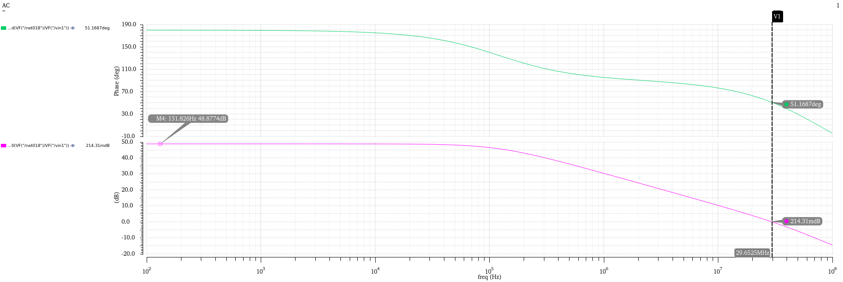
Fig. 4.3 — AC Gain (magenta) and Phase (green) vs. frequency, Vcm = 800mV

5. Summary
- A two-stage Miller-compensated OTA was designed in 45nm CMOS (GPDK045) using I/O devices for 1.8V operation, with L=500nm and a 20µA tail current.
- AC (gain/phase) simulations were performed at two input common-mode points, Vcm = 1.6V and Vcm = 800mV, to verify consistency of the small-signal response.
- Both bias points show a low-frequency gain of =48.88dB, a unity-gain bandwidth of =29.65MHz, and a measured phase margin of =51.17°.
- The measured phase margin of =51.17° at both bias points comfortably meets the target of above 45°, confirming the Miller compensation network provides adequate stability margin for the intended application.
- DC operating-point annotation confirms all transistors remain correctly biased in saturation across both tested common-mode conditions.

